SEG2105 Project Final Report
University of Ottawa Faculty of Engineering

Members: Alexander Su (300081295), Ritvik Johar (300074686)
Professor: Hussein Al Osman
Due Date: Sunday, December 6th, 2020
Section: A
Footnote:
Please be aware due to timing constraints. Deliverable 2 and 3 are in a separate repository in our group. Deliverable 4 has been tagged as v0.4 as our final project as it stands as I was unable to push the updated project onto GitHub, therefore I have to make another repository for the final deliverable and they remain separate.
Introduction:
This report documents the development of a Service Novigrad app made via Android Developer by Alexander Su and Ritvik Johar. The app’s intended purposes are to cater to three different groups: the customer or residents , the Service Novigrad employees and the administrator. Service Novigrad is a generic government services act intended to streamline government services to residents in Ontario. Branch employees can access the app managing their work and processes with the government. Administrators oversee operations including the employees.
In this report, we will present our final UML diagram, as well as any concerns or lessons we’ve learned during the course of the development of our app. Followed by allocations of work between the groups members before finally presenting screenshots of our app.

UML Diagram:
The following UML Diagram was amended for the final deliverable. A separate PDF file has been attached to our repository as well for better clarity.
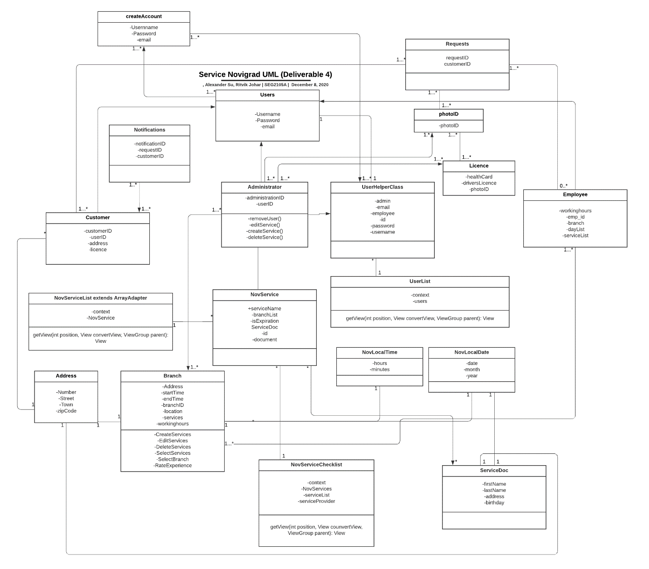

Allocation of work:
Please understand that this team was formed after deliverable 2. Allocations of work for deliverable 1 will not be available. Deliverable 2 has been merged with deliverable 3.
Group members/Deliverables | Deliverable 2/3 | Deliverable 4
Alexander Su | UML Diagram  Development of the app:  - Amending errors | UML Diagram  Final Report  Development of the app  - Amending errors  Presentation of the app via video
Ritvik Johar | Development of the app:  - Amendments to the app for deliverable 2 and 3 | Development of the app:  - Amendments to the app for the final deliverable.

Reflections:
Given the unique circumstances of this school term, distance learning has impaired some of our ability to coordinate and function properly as a group.
The Service Novigrad app we’ve produced after deliverable 4 isn’t perfect. But at it’s state is presentable as the final project given the circumstances that us two had face during the period of this course.
Given our previous group has disbanded, we were forced in our position to create a new group to complete the rest of the project with only two people.
Beyond the point, the project’s intended purpose was to introduce ourselves into the development of software. In this case, developing an app for use of Android OS. Applications for developing software taught in class online proved useful despite the circumstances. In designing the UML diagram for this project, we were able to coordinate the means in how we would achieve the deliverable goals in hopes of making a Service Novigrad app that works as intended.
Given this reflection, we hope that whether if the sudden change in groups were not to happen we would’ve presented a more functional Service Novigrad app than the produced product we have created. Lack of coordination and abrupt changes in groups had not allowed us to finish the Service Novigrad to perfection.

Lessons learnt:
- How apps are developed via Android Studio for Android operated devices.
- Designing UML Diagrams and implementing for use.
- Learnt about Android SDK
- Emulator
- Using Git repository to upload project to GitHub
- APK Files
- Firebase
- CircleCI
- OOP

Screenshots:
